1. **Write a program to Print Fibonacci Series using recursion.**

def fibonacci(n):

if n <= 1:

return n

else:

return fibonacci(n - 1) + fibonacci(n - 2)

def print_fibonacci_series(length):

for i in range(length):

print(fibonacci(i), end=" ")

n = 5

print(f"The Fibonacci series up to {n} terms is:")

print_fibonacci_series(n)

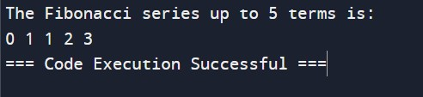

1. **Write a program to check the given no is Armstrong or not using recursive function.**

def count_digits(num):

if num == 0:

return 0

return 1 + count_digits(num // 10)

def is_armstrong(num, n=None):

if n is None:

n = count_digits(num)

if num == 0:

return 0

else:

return ((num % 10) ** n) + is_armstrong(num // 10, n)

number = int(input("Enter a number: "))

sum_of_powers = is_armstrong(number)

if sum_of_powers == number:

print(f"{number} is an Armstrong number.")

else:

print(f"{number} is not an Armstrong number.")

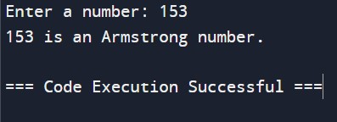

1. **Write a program to find the GCD of two numbers using recursive factorization .**

def gcd_recursive(a, b):

if b == 0:

return a

else:

return gcd_recursive(b, a % b)

num1 = 48

num2 = 18

result = gcd_recursive(num1, num2)

print(f"The GCD of {num1} and {num2} is {result}.")

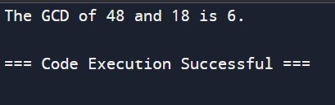

1. **Write a program to get the largest element of an array.**

def find_largest_element(arr):

if len(arr) == 0:

return None

max_element = arr[0]

for element in arr[1:]:

if element > max_element:

max_element = element

return max_element

array = [3, 1, 4, 1, 5, 9, 2, 6, 5, 3, 5]

largest_element = find_largest_element(array)

if largest_element is not None:

print(f"The largest element in the array is {largest_element}.")

else:

print("The array is empty.")

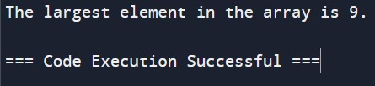

1. **. Write a program to find the Factorial of a number using recursion.**

def factorial(n):

if n == 0:

return 1

else:

return n * factorial(n-1)

num = int(input("Enter a number: "))

if num < 0:

print("Factorial is not defined for negative numbers.")

else:

print(f"The factorial of {num} is {factorial(num)}")

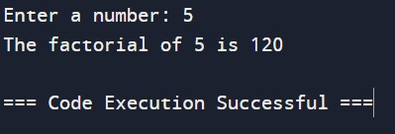

1. **Write a program for to copy one string to another using recursion.**

def copy_string(source, destination, index=0):

if index == len(source):

return destination

destination += source[index]

return copy_string(source, destination, index + 1)

source_str = "Hello, World!"

destination_str = ""

result = copy_string(source_str, destination_str)

print("Source String:", source_str)

print("Copied String:", result)

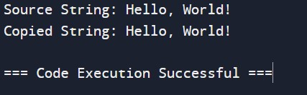

1. **Write a program to print the reverse of a string using recursion.**

def reverse_string(s):

if len(s) == 0:

return s

else:

return reverse_string(s[1:]) + s[0]

input_string = input("Enter a string: ")

print("Reverse of the string:", reverse_string(input_string))

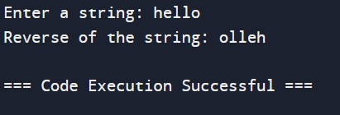

1. **Write a program to generate all the prime numbers using recursion.**

def is_prime(n, divisor=2):

if n <= 1:

return False

elif divisor > n // 2:

return True

elif n % divisor == 0:

return False

else:

return is_prime(n, divisor + 1)

def generate_primes(limit, current=2, primes=[]):

if current > limit:

return primes

elif is_prime(current):

primes.append(current)

return generate_primes(limit, current + 1, primes)

limit = int(input("Enter the upper limit: "))

prime_numbers = generate_primes(limit)

print("Prime numbers up to", limit, "are:", prime_numbers)

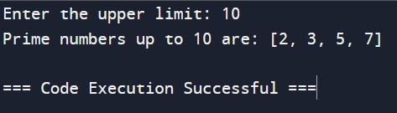

1. **Write a program to check a number is a prime number or not using recursion.**

def is_prime(n, divisor=2):

if n <= 1:

return False

elif n == divisor:

return True

elif n % divisor == 0:

return False

else:

return is_prime(n, divisor + 1)

num = int(input("Enter a number: "))

if is_prime(num):

print(f"{num} is a prime number.")

else:

print(f"{num} is not a prime number.")

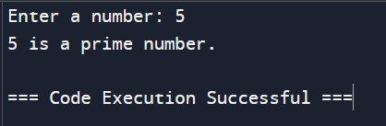

1. **Write a program for to check whether a given String is Palindrome or not using recursion.**

def is_palindrome(s):

s = s.lower()

if len(s) <= 1:

return True

elif s[0] == s[-1]:

return is_palindrome(s[1:-1])

else:

return False

input_string = input("Enter a string: ")

if is_palindrome(input_string):

print(f"{input_string} is a palindrome.")

else:

print(f"{input_string} is not a palindrome.")

